Assembly Instructions for Servo Wordclock
- attach LED PCBs to gear racks
- lay rack on flat surface so that PCB is flush with bottom of rack
- use screws M2.2 x 6

- assemble housing top and bottom parts
- use epoxy for gluing
- use gluing jig for proper alignment
- attach servos to housing
- cables should point towards LEDs
- use screws included with servos
- prepare PCA9685 servo boards
  - solder pin headers
  - solder address jumpers
board no. 1: no solder jumper (binary 00000, Dec 0)
board no. 2: solder jumper A0 (binary 00001, Dec 1)
board no. 3: solder jumper A1 (binary 00010, Dec 2)
board no. 4: solder jumpers A1, A0 (binary 00011, Dec 3)
….
board no. 11: solder jumpers A3, A1 (binary 01010, Dec 10)

- attach PCA9685 boards and zip tie mounts
- use M2.5 x 2.5 spacers for servo boards
- use screws M2.2 x 6 for servo boards and zip tie mounts
- screw terminals on PCA9685 boards should point away from the servos
- attach servo cables to boards
- ch 0 on board is connected to servo on the right end in the picture below
- cables can be guided and fixed with zip ties as shown in the picture below
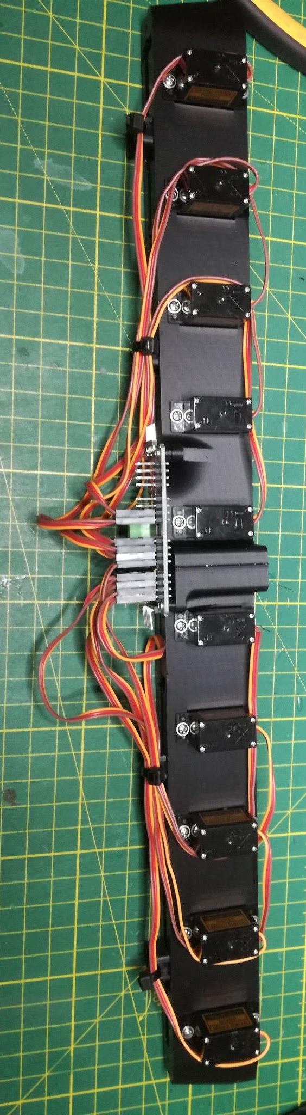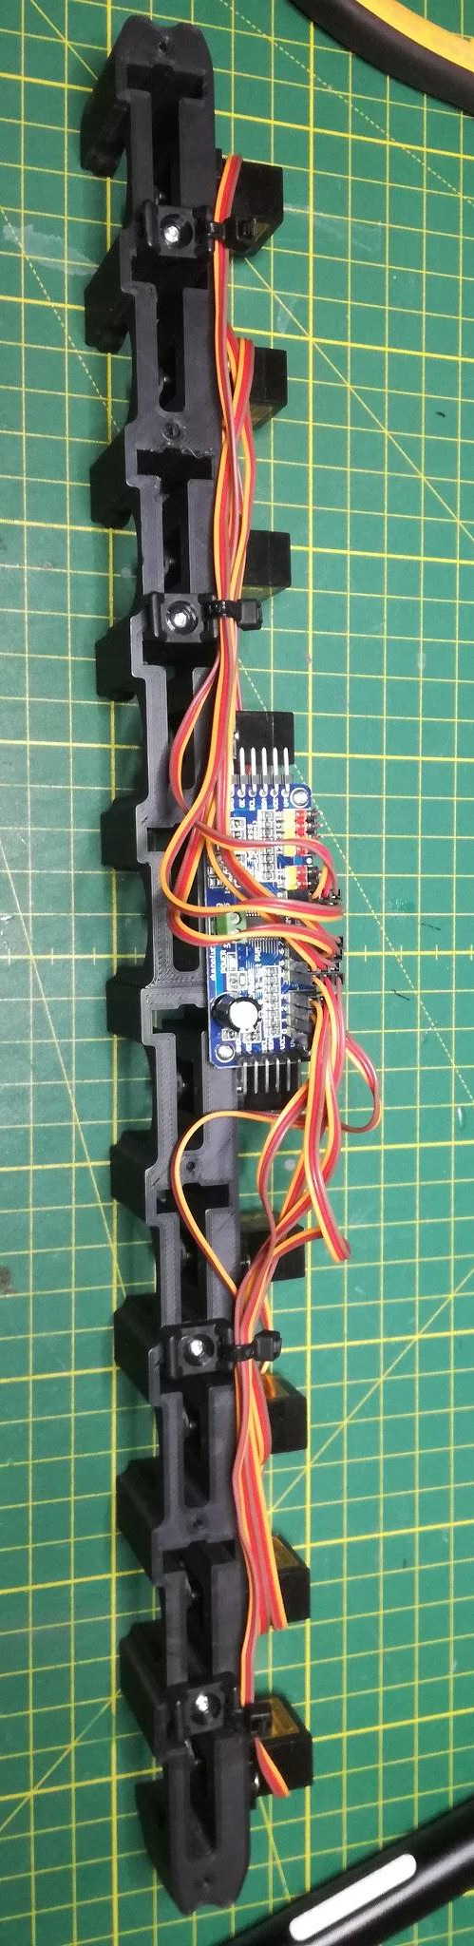
- zeroing all servos
  - upload the code Servo-Word-Clock\code\servo_zeroing\servo_zeroing.ino to ESP8266
  - connect ESP8266 to PCA9685 board
VCC -> 3.3V
V+ -> Vin
GND -> GND
SDA -> D2
SCL -> D1
  - power ESP8266 through USB port
  - all servo motors will go to maximum position one by one
  - disconnect ESP8266 from USB port within two seconds after servos have moved
  - keep ESP8266 connected to PCA9685 board (see step 9.d. below)

- connect all LED PCBs
- use short JST cables
- polarity does not matter but for clarity plug the red cable into VCC

- insert gear racks and attach round gears
  - to reduce friction you can use a dry lubricant like teflon spray
  - align gear racks with alignment jig as shown below
  - attach round gear with screw included with servo; alignment jig should stay in place so that servo gears will not accidentally move when screw is fastened
  - after all gears were attached, remove alignment jig and reconnect ESP8266 to power via USB
    - all motors will stay at the same position for some time
    - after few seconds all servos will move to the minimum position
    - disconnect ESP8266 from servo board

Important Note: The minimum and maximum positions may differ for different servo brands. In this case you need to adjust the values SERVOMIN and SERVOMAX in the files Servo-Word-Clock\code\servo_zeroing\servo_zeroing.ino and also in the main code in Servo-Word-Clock\code\ServoWordClockESP8266\LedMatrix_functions.h

- the shorter column with only 4 servos does not have its own PCA9685 board; for steps 7. and 9. you can connect the servos to the spare channels on another board
- attach snap fit letter boxes to LED PCBs
- if you look at the matrix of letters from the front the servo board with address 0 should be located on the right, the one with address 10 on the left; the servos connected to channel 0 should be on the top and channel 9 on the bottom
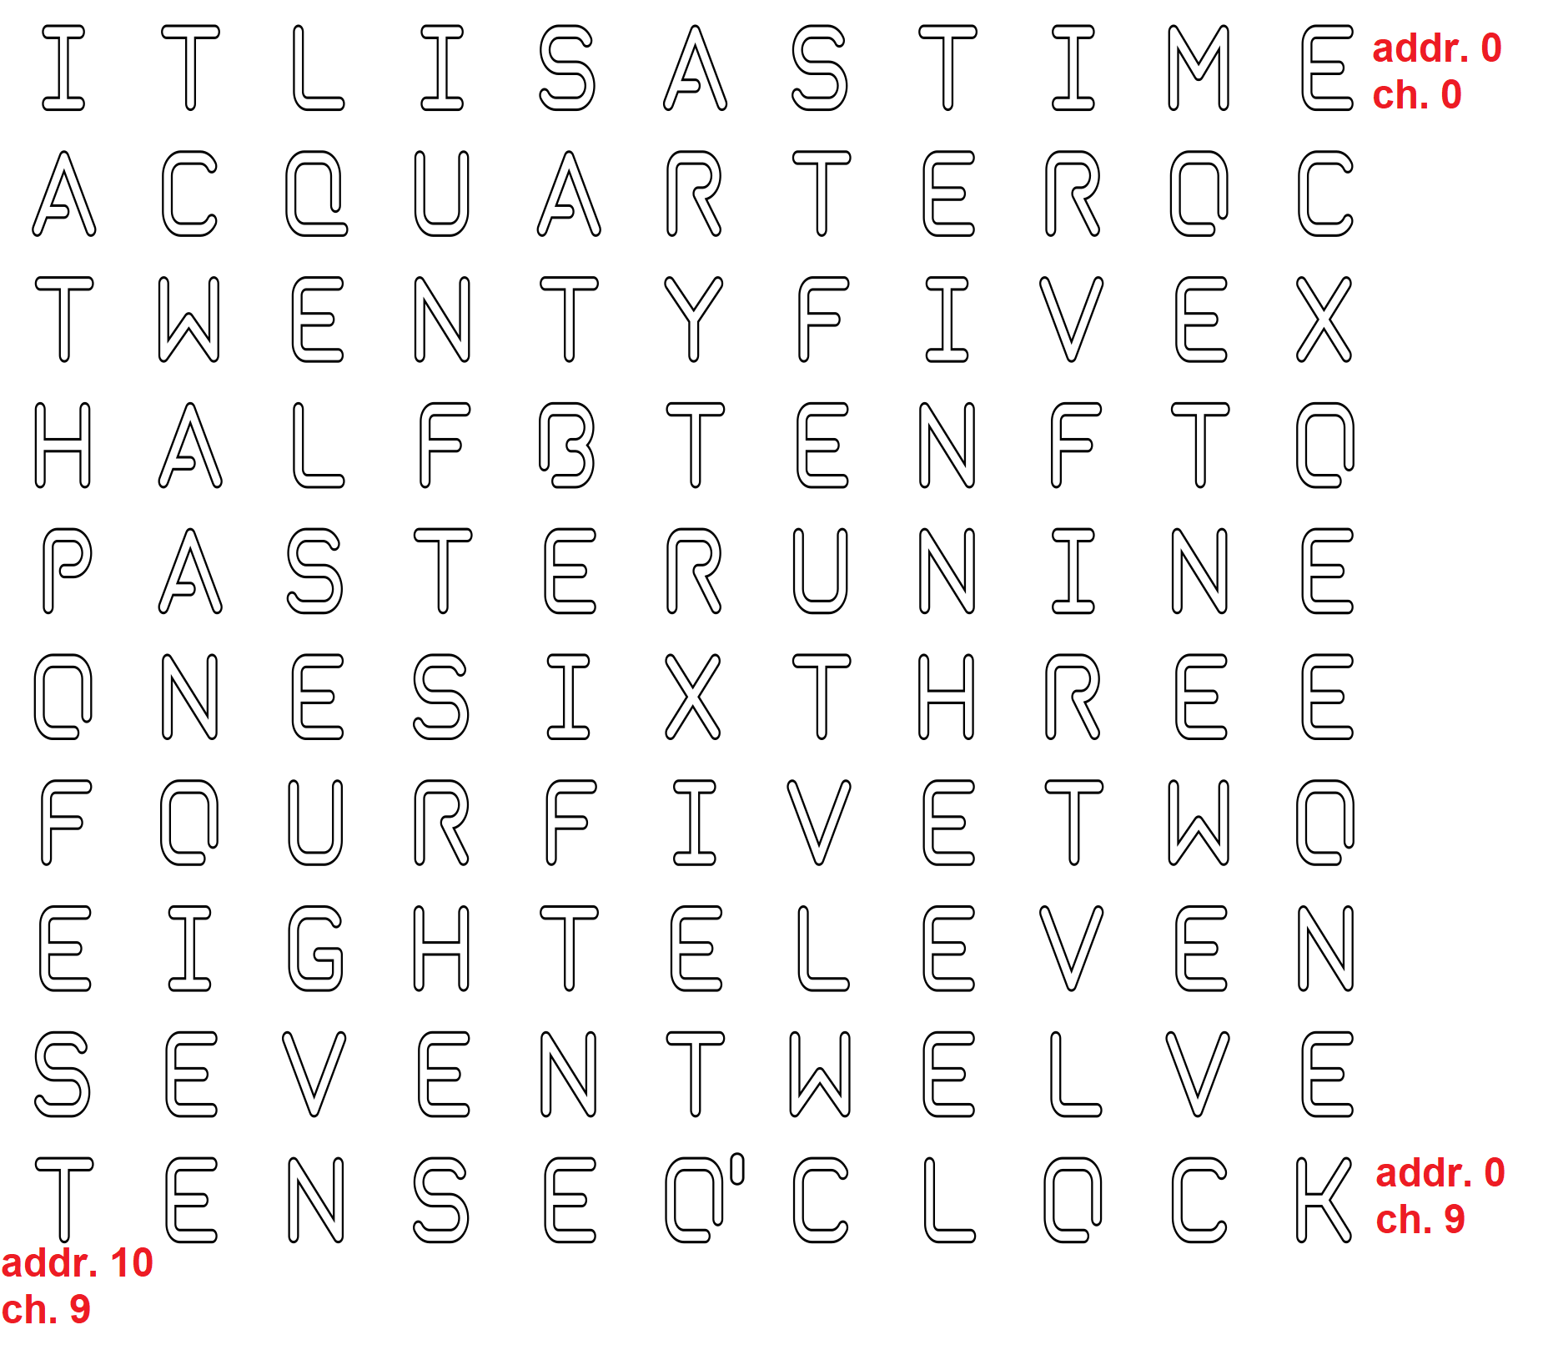
- prepare center frame
  - remove protective foil from both sides
  - place frame on 32mm long columns with the side facing upwards as shown in the picture below; add some spacers in the center to support the frame

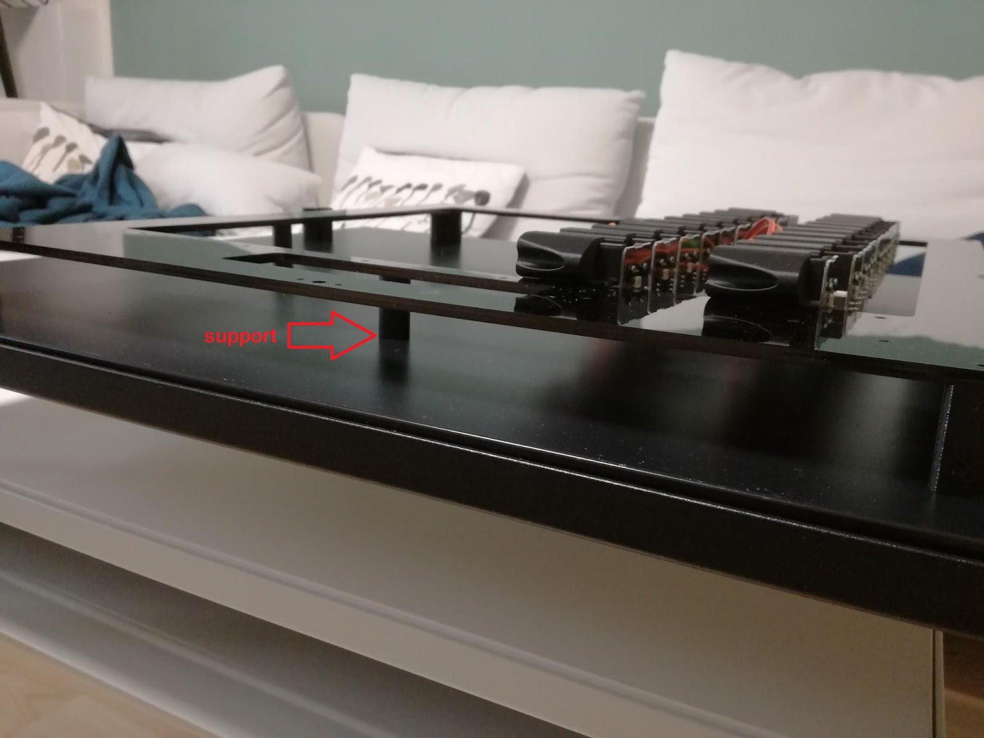

- attach servo columns to frame
- from the rear view, the servo board with address 0 will be on the leftmost position
- use screws M4x12, holes in frame need to be threaded first
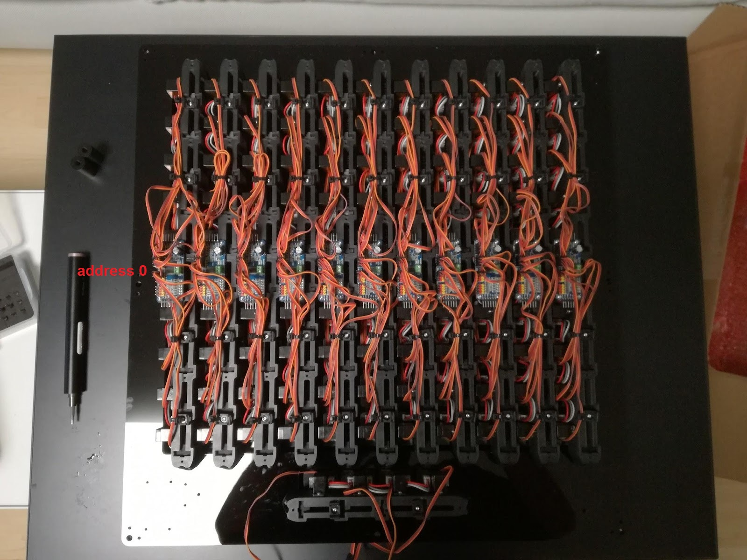

- attach servos of short column with dots to other servo boards
- dot no. 1 (leftmost position, rear view) connected to ch 15, board address 3
- dot no. 2 connected to ch 15, board address 4
- dot no. 3 connected to ch 15, board address 5
- dot no. 4 (rightmost position, rear view) connected to ch 15, board address 6

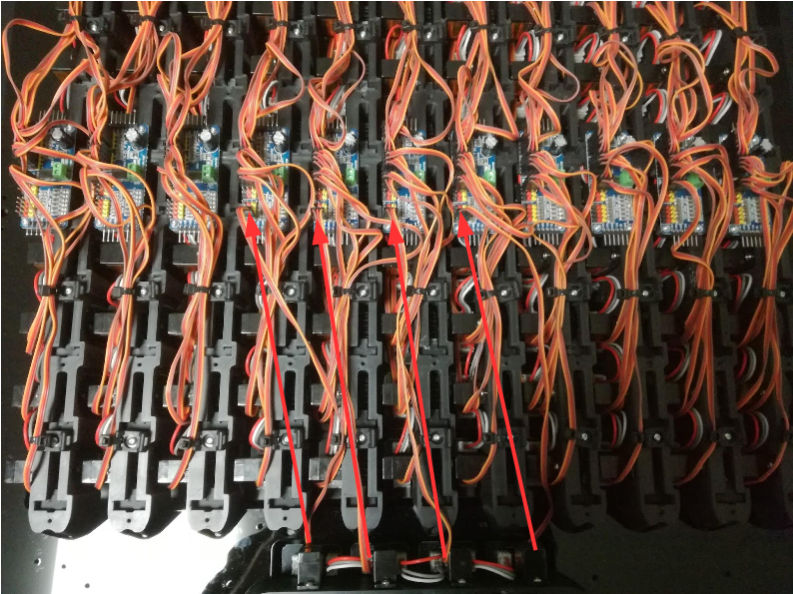
- connect LEDs between columns
- connect first LED (upper position) of column 0 (leftmost position) to last LED (bottom position) of column 1, first LED of column 1 to last LED of column 2 and so on; use long JST cables
- polarity does not matter but for clarity connect red cable to VCC
- later on every second column VCC and GND cables need to be connected to the power supply (see step 20.); therefore remove VCC and GND cables on columns 1, 3, 5, 7 and 9 from the top connector by pulling them out from the JST plug; for these connectors only the data line in the center should remain in the plug (note: in the picture this is only shown for two columns)

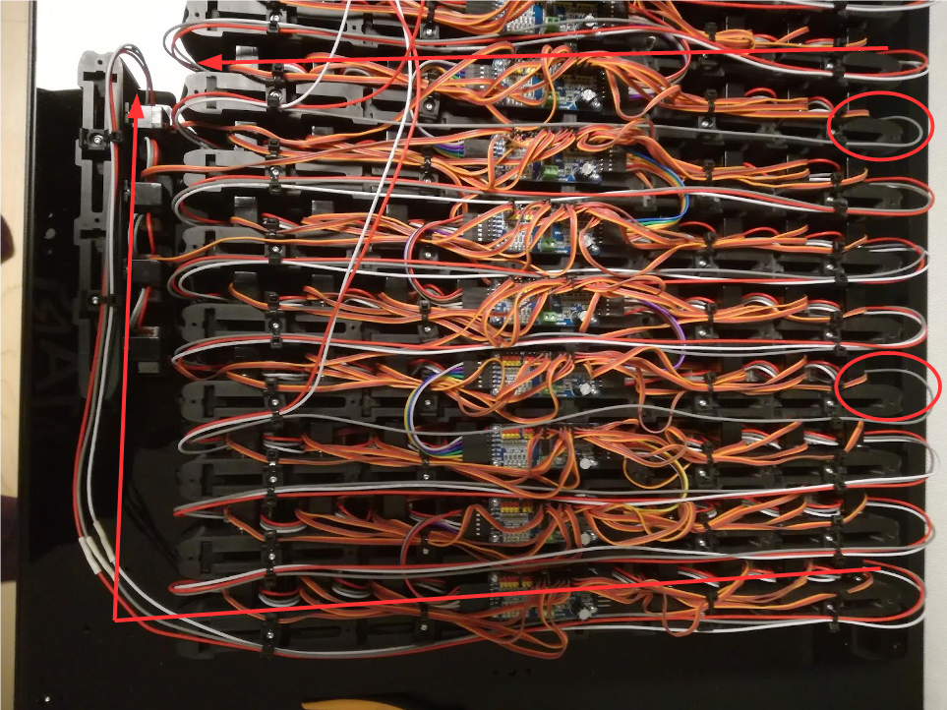

- connect LEDs on the dot row
- dot 1 (leftmost position) should be connected to column 10 (rightmost position)
- for this you need to increase the length of the JST cable by soldering two of them together; shorten the cable to the proper length but keep the rest for later
- fasten LED cables and servo cables on dot row with zip ties

- interconnect all servo boards
- use 1x6 dupont cables
- take care of correct polarity

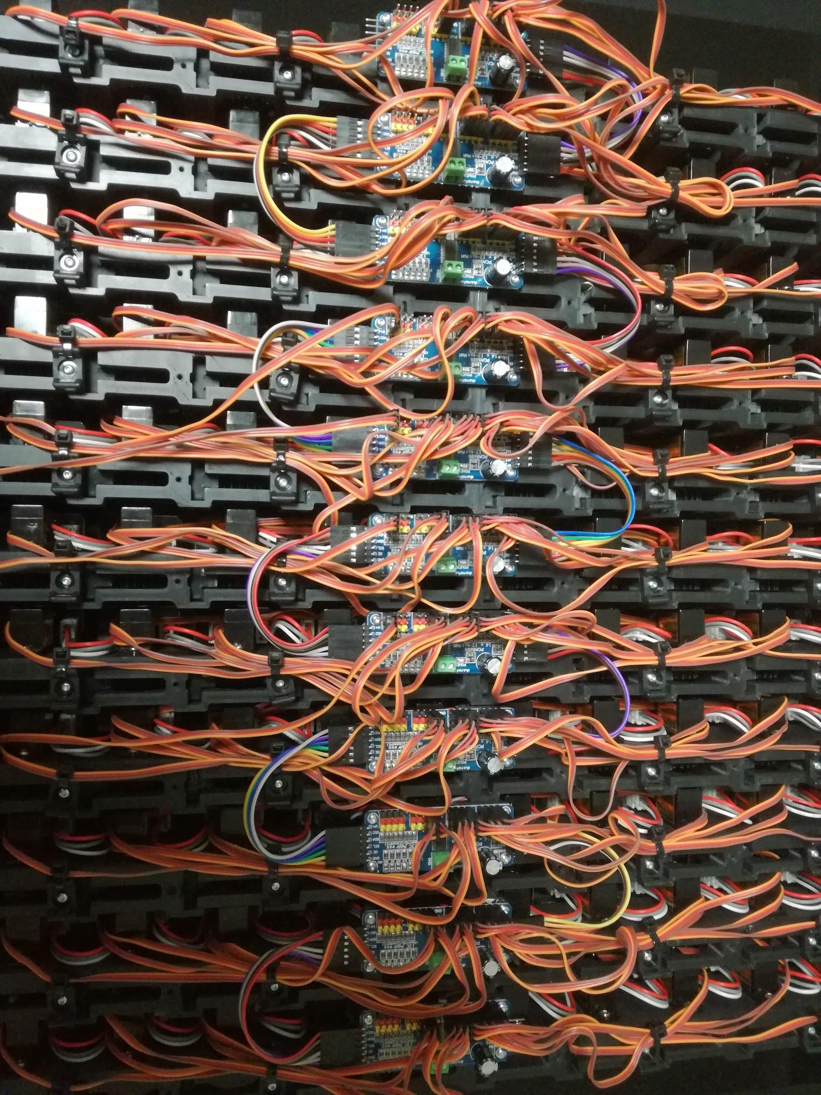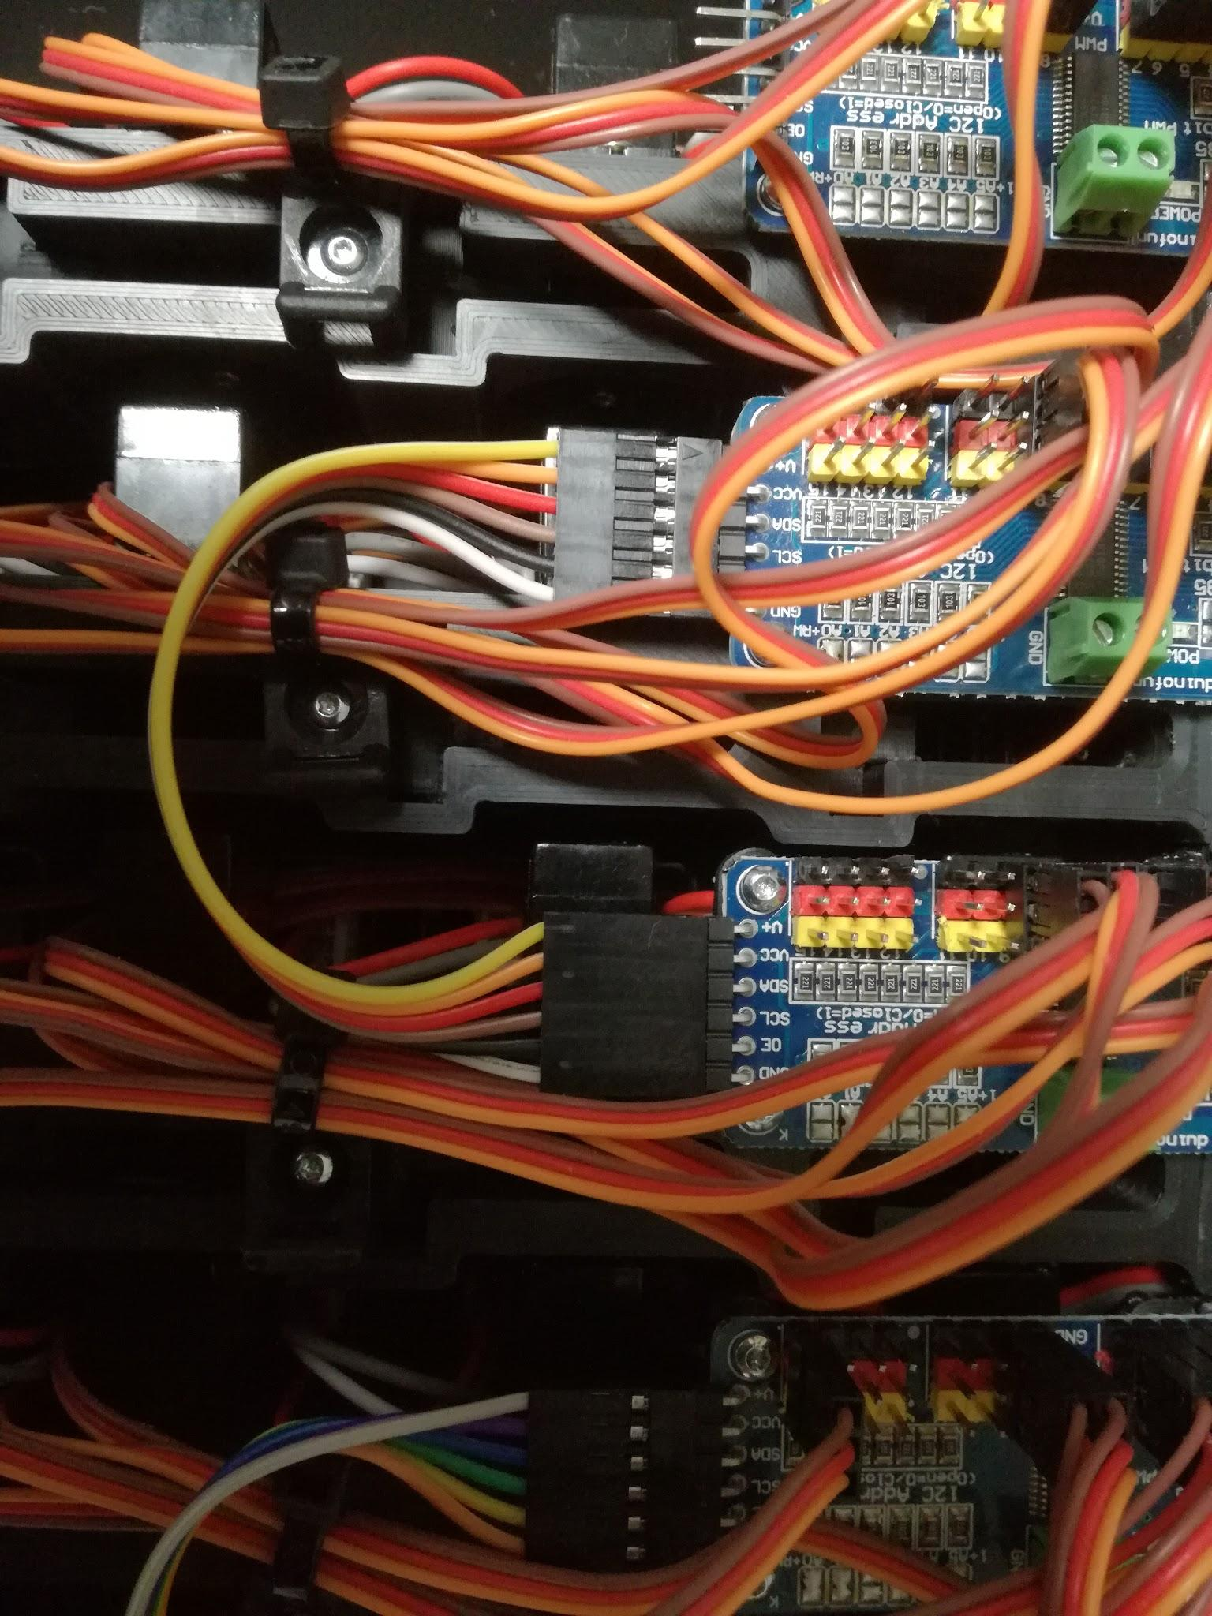
- attach long screw terminals to frame
- use included spacers
- use screws M3x12, holes in frame need to be threaded first
- for correct orientation see picture below
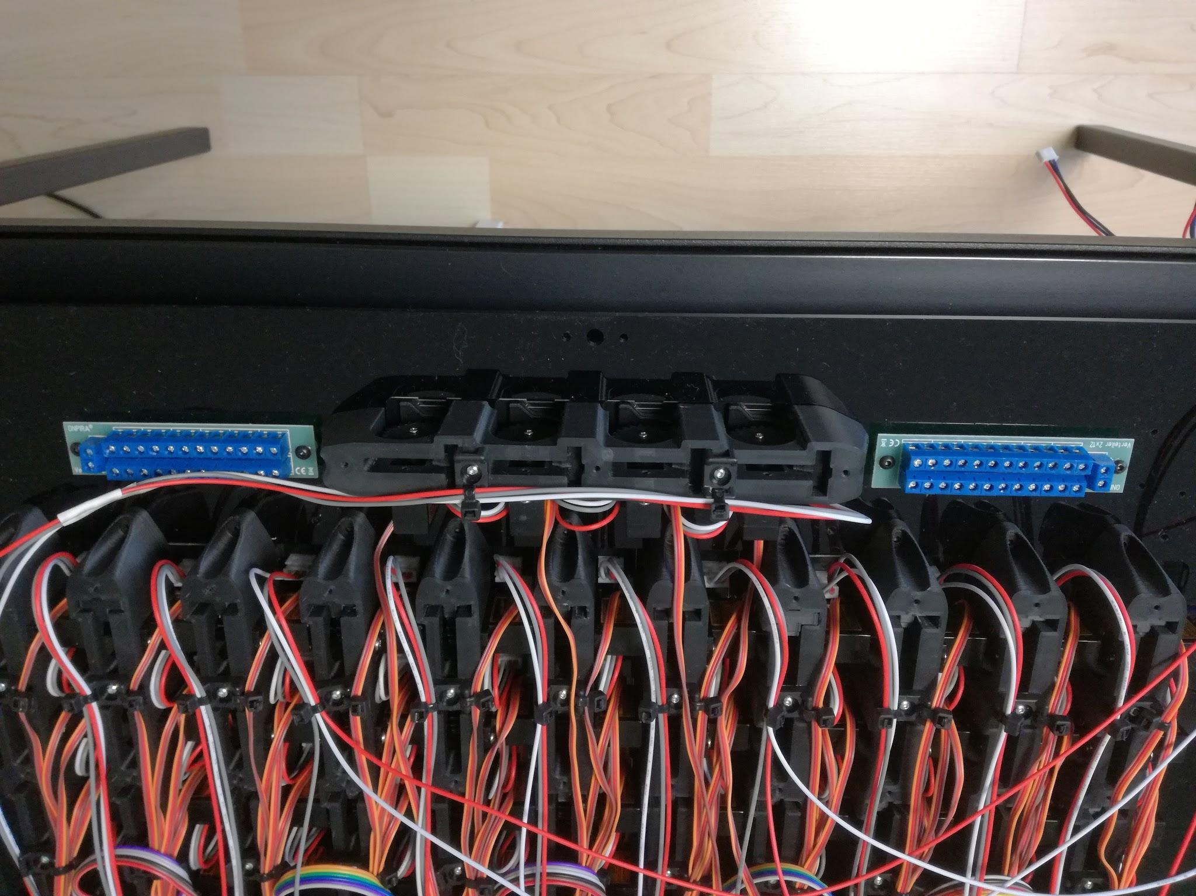
- interconnect both screw terminals
- prepare red and black cable with cross section 0.34mm2 with cables sleeves (green color) on both ends; you can use the rest of the LED cable from step 16.
- connect power supply for LEDs
- attach cable sleeves (green color) to VCC and GND cables of rows 1, 3, 5, 7, and 9 (see step 15.)
- take care of correct polarity

- connect power supply for servo boards
- prepare cable with 0.22mm2 cross section and cable sleeves (purple color) on both ends
- take care of correct polarity
- fasten all cables with zip ties
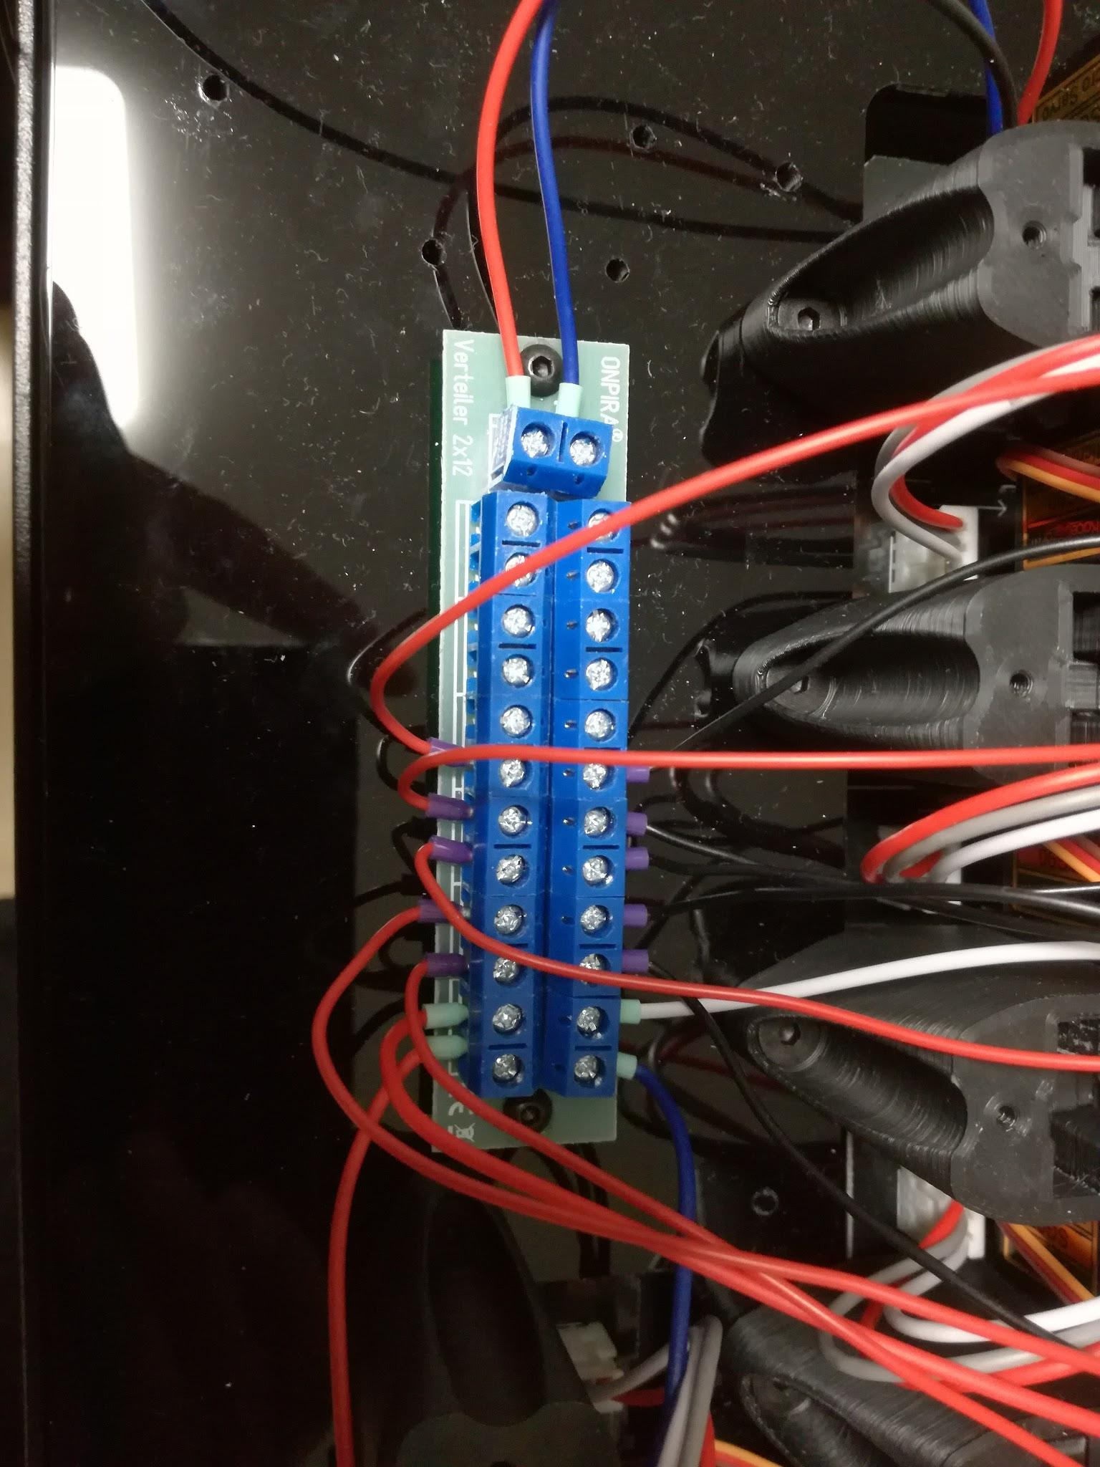
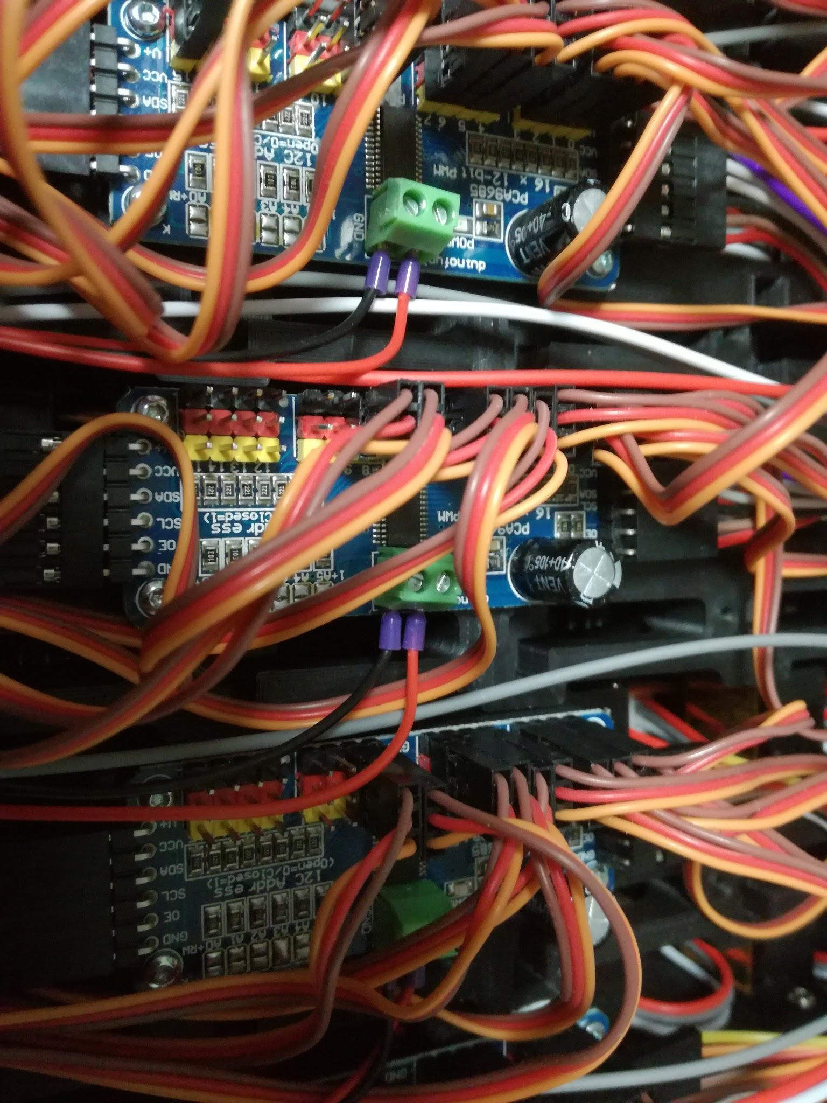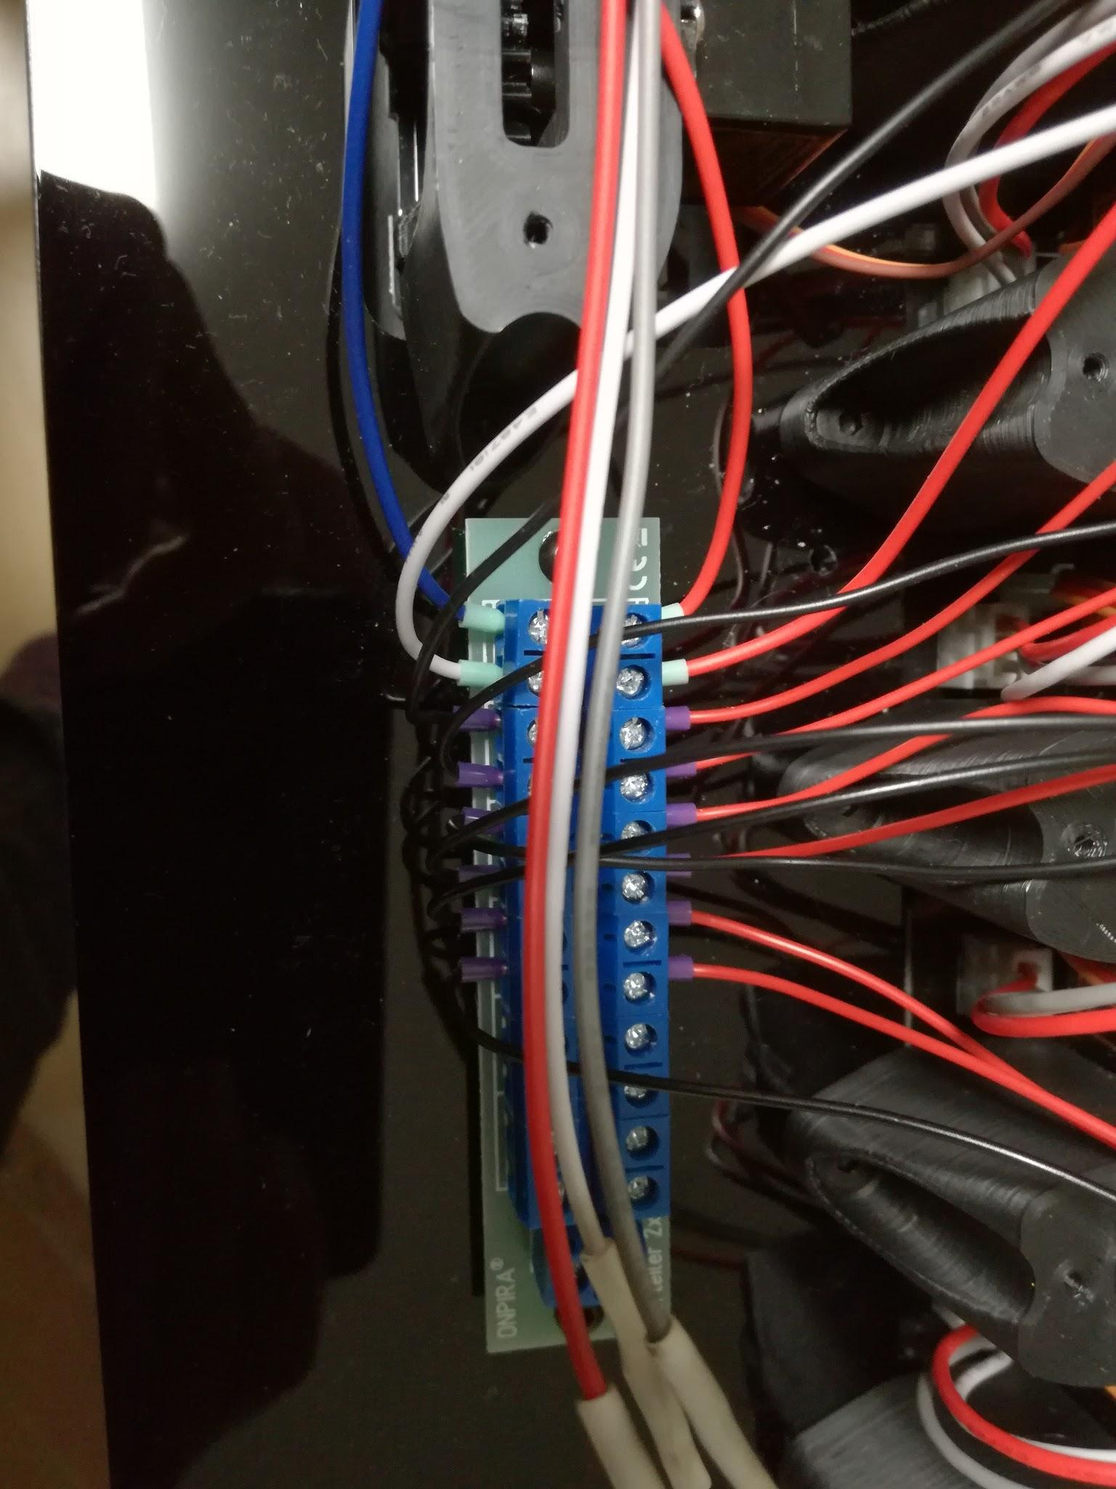

- Upload Servo Wordclock firmware to ESP8266
- Follow instructions in Servo-Word-Clock\code\README.MD
- Prepare main PCB
- Solder all components to main PCB as shown in the picture below
- take care of proper polarity for the capacitor
- take care of proper orientation of the level shifter
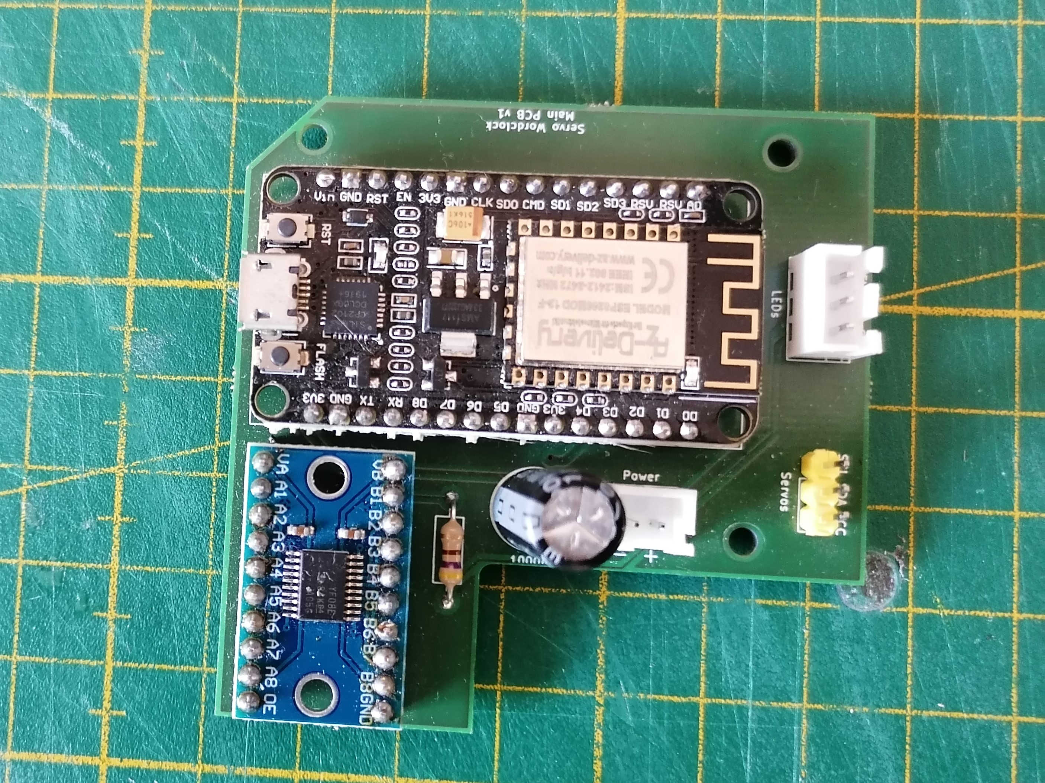
- Attach main PCB to frame
- PCB goes in bottom left corner
- use M2.5x5.5 spacers and M2.5x12 screws, holes in frame need to be threaded first
- Connect main PCB
- connect power on main PCB to screw terminal on frame (take care of proper polarity)
- connect first servo board
- connect first LED
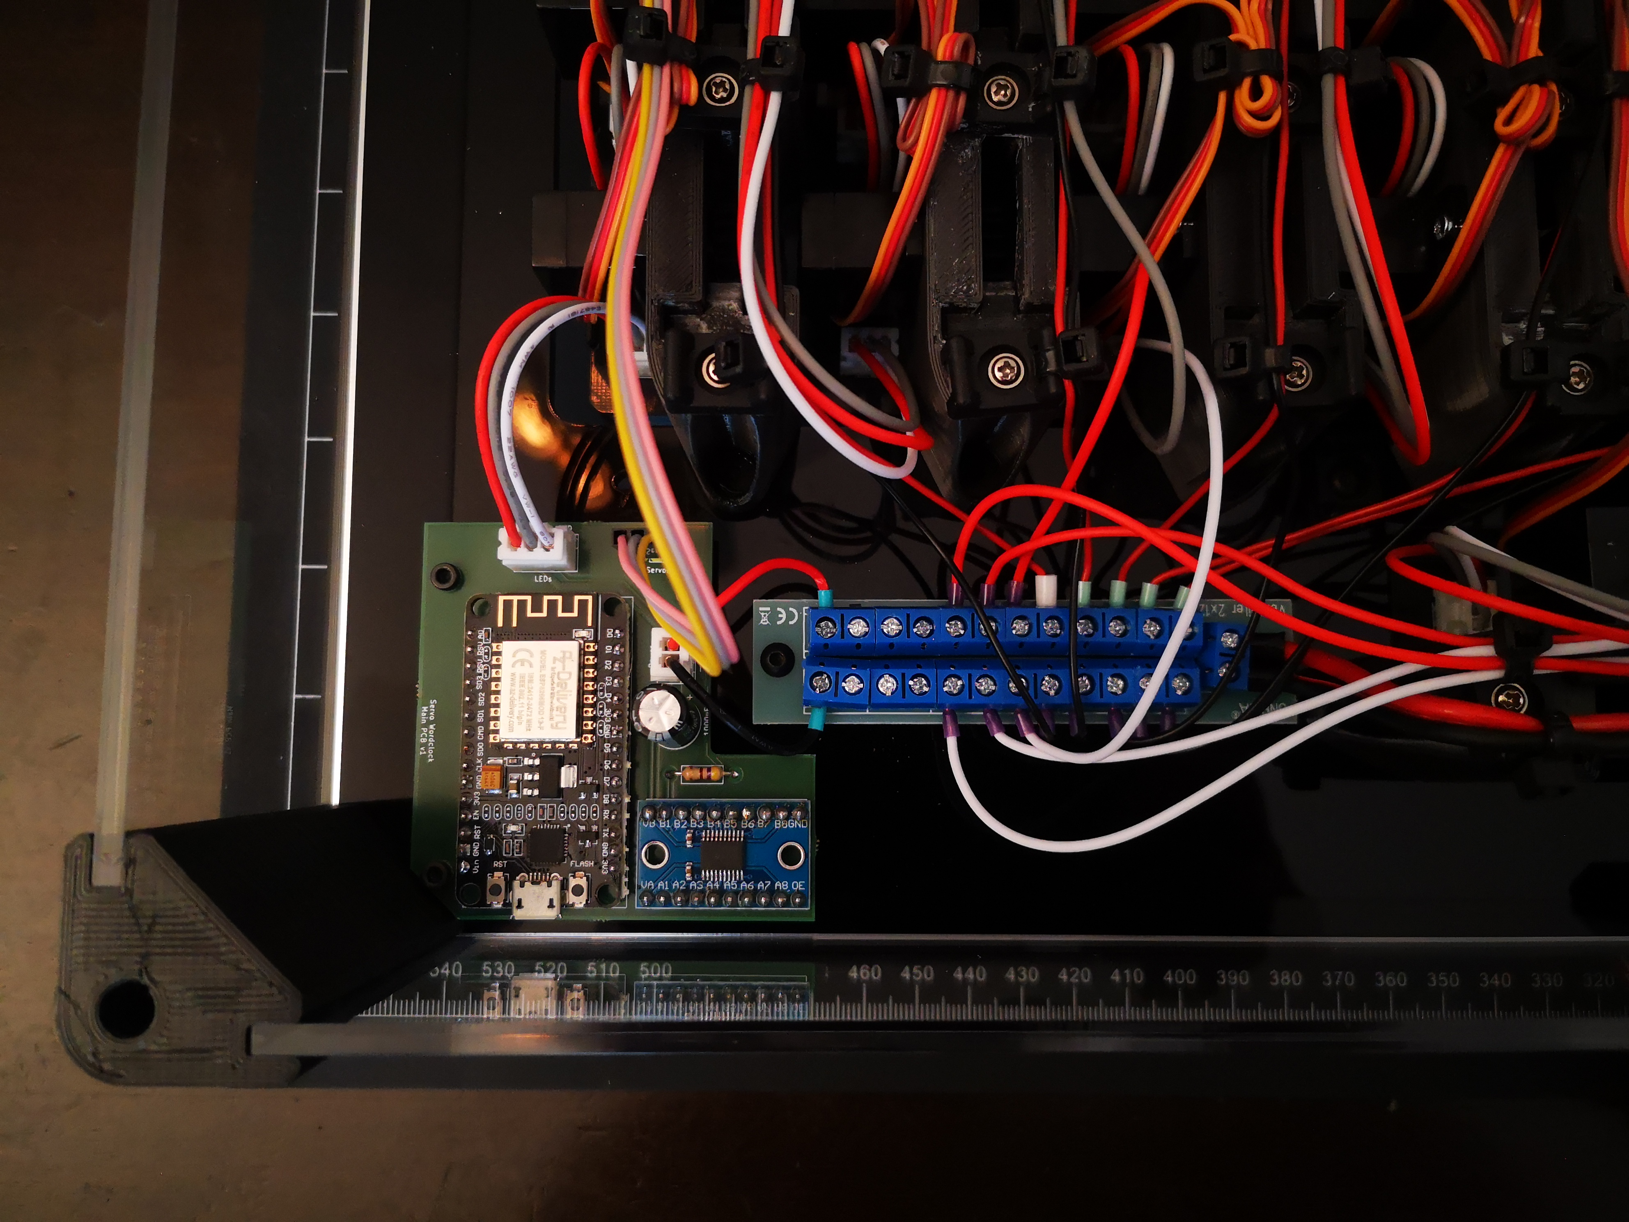
- place long columns on frame
  - column with cable feed through should be placed on bottom right corner (rear view)
  - center columns with shorter slot go on left/right side
  - center columns with longer slow go on top/bottom side
- insert side panel with hole for switch into bottom right corner
- attach switch to side panel
- attach DC cable to switch and screw terminal
  - solder positive voltage line (brown) to switch or attach with 4.8mm cable shoes (not included)
  - solder cable with 0.5mm2 cross section to switch (or use cable shoe) and attach other side to screw terminal (use cable sleeve)
  - attach negative voltage line (blue) directly to screw terminal
  - attach 3D printed cable holder to frame as strain relief (note: picture shows different cable holder)

- insert all remaining side panels
  - you can leave the protective foil on the outside and remove it later

- prepare back panel
  - remove protective foil from side without engraving
  - glue 3D printed boxes on side without engraving

- attach back panel
  - use M6x90 screws for corner columns
  - use M6x16 screws on both sides for center columns

- prepare screen
  - remove protective foil from one side
  - attach self-adhesive diffusor film in center; spray panel with soap water to avoid bubbles

- attach screen
  - use M6x16 screws
- Done!
- Remove the remaining protective foil
- connect clock to power supply
- follow instructions in Servo-Word-Clock\code\manual.pdf



